Name ___________________________________ Class ________

World Map Quiz Preparation

Directions: Label the following locations on the map on the reverse side of this sheet. Make sure that all labels are easy to read and use arrows if needed.

CONTINENTS: Europe South America
Asia North America
Africa Australia
- Antarctica

OCEANS: Pacific Ocean Indian Ocean
Atlantic Ocean Arctic Ocean

OTHERS: (You will need to draw your own lines for Tropic of Capricorn and Tropic of Cancer)
Equator Prime Meridian
Tropic of Capricorn Tropic of Cancer
United States of America North Carolina (put star on map with arrow)

There will be a world map quiz in class on ________________________________________.
*** Use your labeled map to study for the quiz. ***

Name ___________________________________ Class ________

World Map Quiz Preparation

Directions: Label the following locations on the map on the reverse side of this sheet. Make sure that all labels are easy to read and use arrows if needed.

CONTINENTS: Europe South America
Asia North America
Africa Australia
- Antarctica

OCEANS: Pacific Ocean Indian Ocean
Atlantic Ocean Arctic Ocean

OTHERS: (You will need to draw your own lines for Tropic of Capricorn and Tropic of Cancer)
Equator Prime Meridian
Tropic of Capricorn Tropic of Cancer
United States of America North Carolina (put star on map with arrow)

There will be a world map quiz in class on ________________________________________.
*** Use your labeled map to study for the quiz. ***

Entry #_______
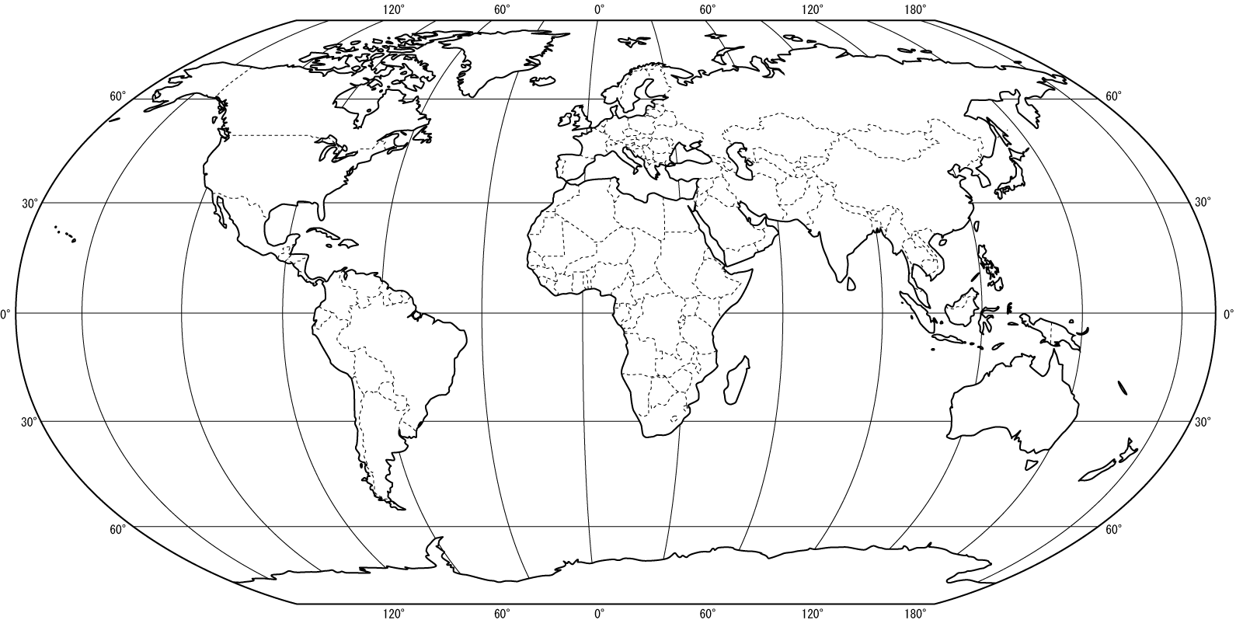
The World Map

