Civilizations of the Americas
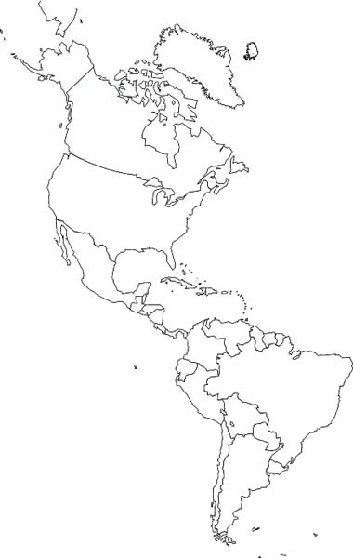
Map Labeling Directions
Use the map on p. 61 (MTT) and 253 label the civilizations, landforms and regions listed below on the map.

Civilizations: Label and color each civilization a different color.
□ Mayas □ Anasazi
□ Aztecs □ Pueblo
□ Incas □ Northwest Coast Peoples
□ Mound Builders □ Iroquois League

Landforms and Bodies of Water: Label each listed below on the map.
□ Andes Mountains □ Atlantic Ocean
□ Great Plains □ Pacific Ocean
□ Yucatan Peninsula □ Gulf of Mexico
□ Rocky Mountains □ Bering Strait
□ Appalachian Mountains □ Mississippi River

Regions: Label each region listed below on the map.
□ North America □ Mesoamerica
□ South America

Map Labeling Directions
Use the map on p. 61 (MTT) and 253 label the civilizations, landforms and regions listed below on the map.

Civilizations: Label and color each civilization a different color.
□ Mayas □ Anasazi
□ Aztecs □ Pueblo
□ Incas □ Northwest Coast Peoples
□ Mound Builders □ Iroquois League

Landforms and Bodies of Water: Label each listed below on the map.
□ Andes Mountains □ Atlantic Ocean
□ Great Plains □ Pacific Ocean
□ Yucatan Peninsula □ Gulf of Mexico
□ Rocky Mountains □ Bering Strait
□ Appalachian Mountains □ Mississippi River

Regions: Label each region listed below on the map.
□ North America □ Mesoamerica
□ South America

