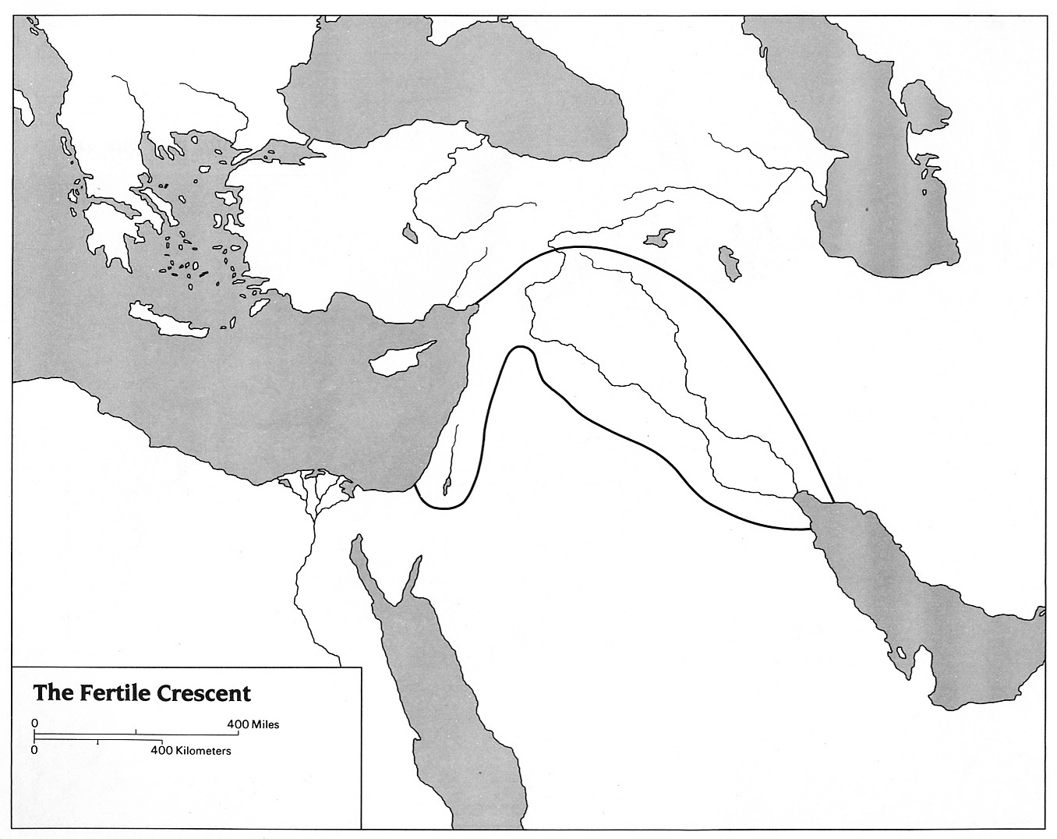
Fertile Crescent Map
Label the following: (Use pp 117, and 123, 146 of the Eastern World textbook)

Ancient City-States:
Babylon
Ur
Jerusalem

Landforms (Color Brown)
Taurus Mountains
Syrian Desert
Zagros Mountains

Bodies of Water (Blue):
Tigris River
Euphrates River
Persian Gulf
Mediterranean Sea

Color these regions:
Sumer – Yellow (p123)
Mesopotamia – Purple
Fertile Crescent – Green

